Project Plan

Hire A Chef

Industry Partner | NA
Primary Instructor | Anjana Shah
Team Member | Gokul Jinu
Team Member | Ans Joju
Team Member | Basil Shaji
Team Member | Nithiyan Annapoorani Valluvan
Team Member

Document Revision History

Revision # | Date
1 | 2024-10-07

Table of Contents

1. Executive Summary

The following describes the project to be executed.

Objective | The objective of the "Hire A Chef" project is to create a digital platform that connects users with private chefs based on budget, dietary preferences, and event needs. The platform will streamline booking, communication, and payments, ensuring a seamless experience for both clients and chefs.
Corporate Goals Addressed | The corporate goals for the "Hire A Chef" project are to streamline the private chef booking process by creating a user-friendly platform that makes it easier for customers to find and book chefs based on their preferences and budget. The platform aims to foster transparency by providing clear pricing, availability, and reviews, ensuring trust and reliability between chefs and clients. Ultimately, it seeks to bridge the gap in the market, making private chef services more accessible and efficient for a broader audience.
Planned Start Date | September-14 2024
Planned End Date | April-20 2024

2. Project Approved by, Reviews and Distribution List

Approvers, reviewers and distribution list

Project Role | Name | E-mail | Date
Reviewers | Ans Joju | Ans.joju@georgebrown.ca | 04-10-2024
Reviewers | Nithiyan Annapoorani Valluvan | Nithiyan.annapooranivalluvan@georgebrown.ca | 04-10-2024
Approvers | Basil Shaji | Basil.Shaji@georgebrown.ca | 04-10-2024
Approvers | Gokul Jinu | Gokul.JInu@georgebrown.ca | 04-10-2024

3. Scope

Define the sum total of all of its products and their requirements or features.

In Scope | Out of Scope
Development of the "Hire A Chef" web platform. | Development of mobile applications (initially focused on the web interface).
Key features including chef profiles, booking system, payment integration, and user reviews. | Services not related to culinary and chef hiring (e.g., event planning or catering).
User registration, chef selection, scheduling, and communication capabilities. | International services and payments (initially limited to local markets).
Chef management system for availability, pricing, and client interactions.

4. Deliverables

This project will deliver the following.

Deliverable | Description
Hire A Chef Platform | Fully functional web platform allowing users to browse, select, and book private chefs.
Chef Booking System | Integrated system for users to search chefs based on budget, dietary preferences, and location, with an easy booking and payment process.
Chef and Client Communication | Messaging and scheduling feature to facilitate communication and coordination between clients and chefs.
Chef Management System | Backend system for chefs to manage their availability, pricing, and client interactions.

5. Assumptions
This project makes the following assumptions:
- Users will have reliable internet access to utilize the platform effectively.
- Users possess basic technology knowledge to navigate and operate the platform.
- Chefs and clients will be willing to engage in online transactions and communication.
- Third-party payment processors and scheduling services will integrate seamlessly with the "Hire A Chef" platform.
- Legal compliance will be maintained regarding food safety, licensing, and e-commerce regulations.
- Users will provide accurate dietary and budget information to ensure appropriate chef matches.

6. Dependencies
The following are the internal and external dependencies that will need to be acknowledged and addressed:
- Hosting and cloud services to ensure reliable platform performance and data storage.
- User verification services for ensuring the authenticity of chef profiles and customer identities.
- Compliance with local food safety regulations to ensure all chefs meet required standards and licensing.
- Data analytics tools for gaining insights into user behavior and platform performance.
- Feedback and support systems to assist users and chefs in navigating the platform and resolving issues.

7. Risk Management

Potential Risk | Severity (H/M/L) | Likelihood (H/M/L) | Management Strategy
Limited user adoption | High | Medium | Implement robust marketing strategies, including social media campaigns and partnerships with influencers.
Chef availability and scheduling conflicts | Medium | Medium | Create a flexible scheduling system and maintain communication with chefs to manage bookings effectively.
Negative user feedback | Medium | Medium | Establish a responsive customer support system to address concerns promptly and incorporate user feedback for improvements.

8. Communication

Reporting

The following reports will be produced;

Report | Audience | Frequency
Completing weekly Sprints | All members | Weekly
Status report | All members | Weekly

Meetings

The following meetings/communication will be established;

Meeting | Purpose | Attendees | Frequency
Tuesday 10-12 | Sprint works | All members | Weekly
Wednesday 12-2pm | Status report | All members | Weekly

9. Task Listing (WBS- Work Breakdown Structure)
The following resource proposal template summarizes the resource hours committed to this project, upon final approval of this document.

Reference | Tasks | Duration | Dependency
A | Project seletion. | 1 week | none
B | Gathering intel and structuring documents | 2 weeks | A
C | Platform and UI/UX Design | 3 weeks | B
D | Database and Backend Development | 4 weeks | C
E | Frontend Development and Integration | 5 weeks | C
F | Payment Gateway Integration | 3 weeks | D
G | Testing and Debugging | 2 weeks | E,F
H | User Feedback and Modifications | 2 weeks | G
I | Final Release and Deployment | 1 week | H

10. Gantt Chart
Create a detailed Gantt Chart from your Task Listing(Use any software tool and paste the image or upload as a separate file that can be opened as pdf/doc/xls)

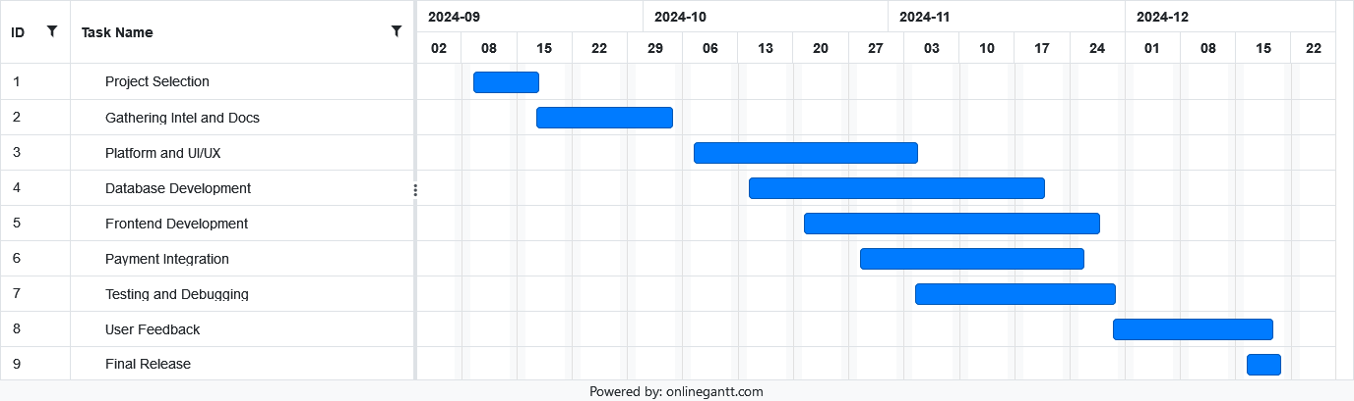

11. Milestones

Major Activity or Milestone | Estimated Milestone Target date | Owner/Reviewer Team Members
Project selection | 09/20/2024 | Team 34
Gathering Intel | 10/04/2024 | Ans Joju
UI/UX Design | 10/25/2024 | Nithiyan Annapoorani Valluvan
Back-end / Database | 11/22/2024 | Basil Shaji
Front-end Development | 12/20/2024 | Gokul Jinu
Payment Integration | 01/10/2025 | Ans Joju
Testing | 01/24/2025 | Team 34
User feedback | 02/07/2025 | Team 34
Final release | 02/14/2025 | Team 34

12. RAM – Responsibility Assignment Matrix

RAM from your Task Listing:
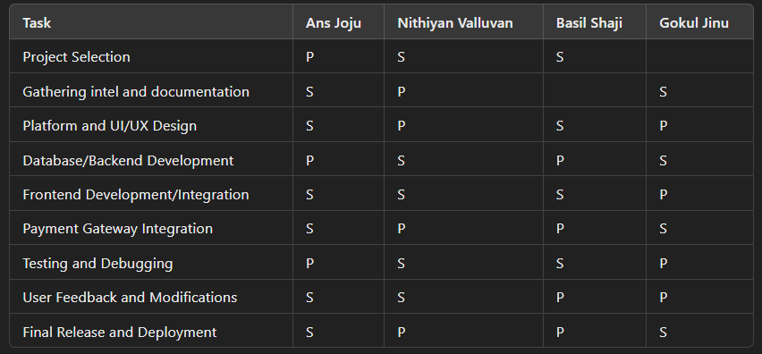

13. Approval

The signatures below indicate their approval of the contents of this document.

Project Role | Name | Signature | Date
Project Manger | Ans Joju |  | 09/20/2024
Lead Developer | Nithiyan Annapoorani Valluvan |  | 09/20/2024
Backend Developer | Basil Shaji |  | 09/20/2024
Frontend Developer | Gokul Jinu |  | 09/20/2024

